COMMUNITY SERVICE PROJECT REPORT
ON
SCHOOL EDUCATION
A project Report Submitted
As part of the Curriculum for the degree of
BACHELOR OF ARTS
By
S.Tauseefa
(Roll No: 21440117016
I BA HUP UM
2021-2022
Under the guidance of the Mentor
SARTAJ MEDAM
Lecturer in Urdu


DEPARTMENT OF URDU
SKR & SKR GOVERNMENT DEGREE COLLEGE FOR WOMEN (A)
JUNE -2022

CERTIFICATE

This is certified that the “Community Service Project on School Education” is the bonafide work done by s.Tauseefa, (Roll No-21440117016)duration of one month (May-June 2022) as part of curriculum for the partial fulfillment of the requirements for the award of BACHELOR OF ARTS by SKR & SKR GOVT. COLLEGE FOR WOMEN (A), Kadapa, Andhra Pradesh.

Signature of the Mentor

ACKNOWLEDGEMENT

I wish to express our deep sense of gratitude and sincere regards to our institution SKR & SKR GDCW(A) Affiliated to Yogi Vemana University Kadapa for providing an opportunity to conduct Community Service Project.
I thank to Dr. P. Subba Lakshumma our beloved principal of SKR & SKR GDCW (A) for allowing us to pursue this project. I am also thankful to my Mentor Smt. SARTAJ MEDAM, Lecturer in Urdu for her valuable guidance and co-operation. My special thanks to family members, ward/Village secretary, friends and families visited for extending their cooperation in completing this project successfully.

(Roll No-21440117016)

CONTENTS

S.No | Name of the content | Page No.
1. | Work done statement
2. | Log book
3. | Questionnaire
4. | Community Survey on  School Education
5. | Introduction
6. | Objective/Scope
7. | Data Analysis
8. | Results and Discussion
9. | Conclusion
10. | Geo tagged Photos
11. | References

Work done statement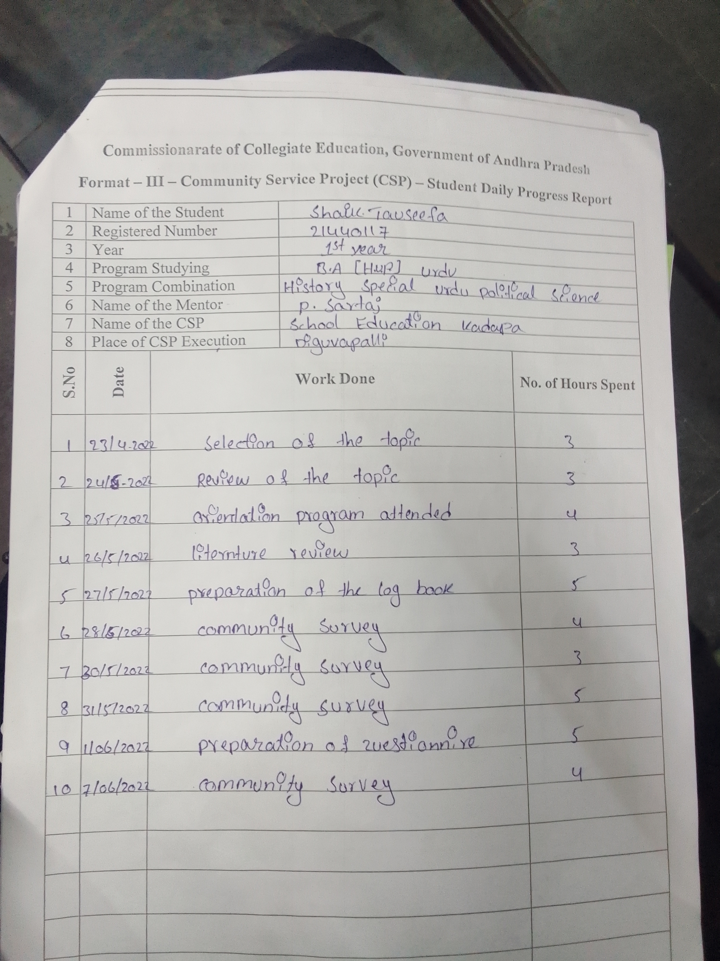

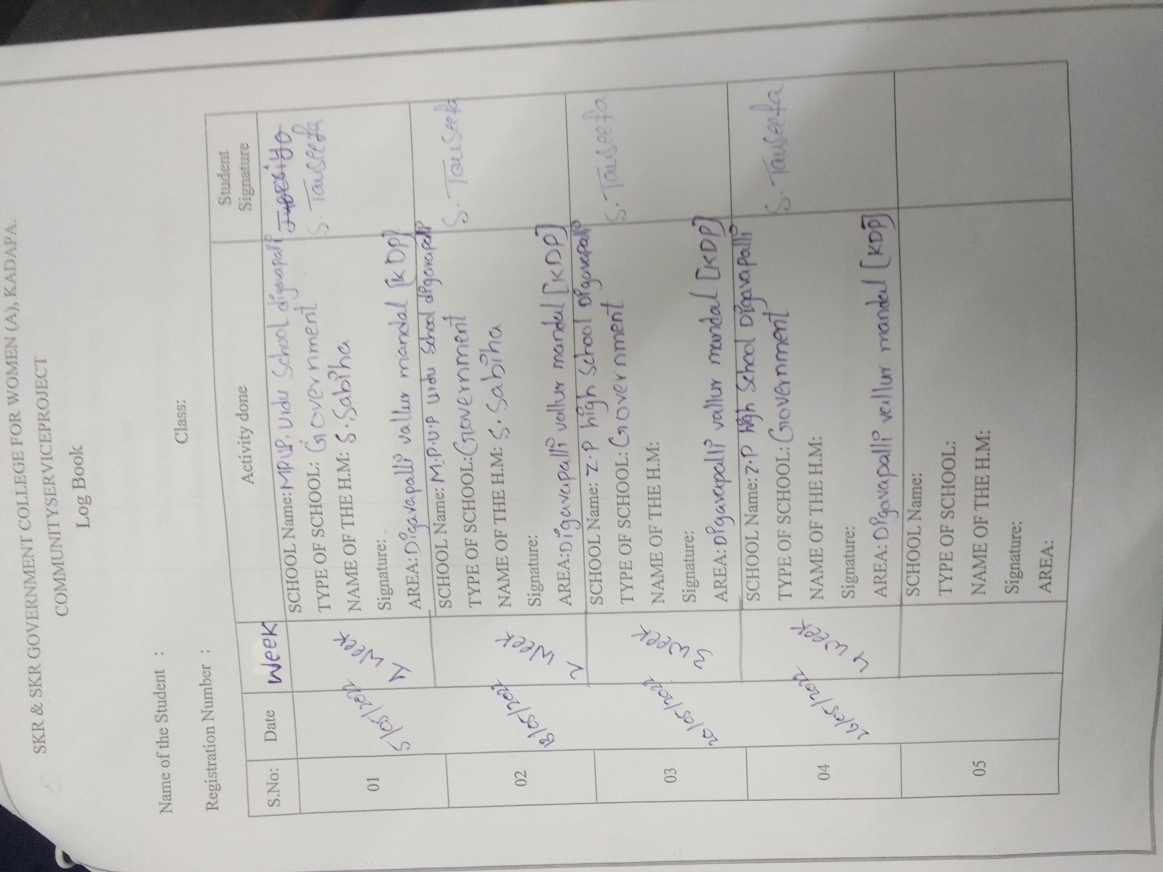

Log book

 | SKR & SKR Govt. DEGREE COLLEGE FOR WOMEN (A),KADAPA.  Y.S.R DISTRICT  NAAC RE-ACCARAGRATION “B” level  (Affiliated to YOGI VEMANA UNIVERSITY)  DEPARTMENT OF URDU  Questionnaire Of the SCHOOL EDUCATION SURVEY IN KADAPA | 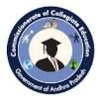
(A COMMUNITY SERVICE PROJECT)
STUDENT NAME | S.Tauseefa
A HALLTCKET NO | 21440117016 | YEAR | I
SEMESTER(I/IV/VI) | 2 | MENTOR NAME | SARTAJ MEDAM
COURSE | BA(UM) | GROUP | HUP
I.
1.NAME OF THE VILLAGE/PANCHAYTHI: Bayanapalli
2.WARD/CORPORATION NO: 9 ward
3.Name of the corporate: k.Harikeshva reddy
4.Name of the School MEo. Sadak vali
5.Name of Voluntary: Siva Naga jyothy
6.Name of the Sarpanch K.harikeshvareddy
I .About the School:
- Date of Establishment the School:
2001
- Type of the School: (Govt./ZP/Private/Corporate)
Govt

- School status: ( High school/ Upper Primary/Primary/AaganVadi School
II. StudentsStrength of the school (Numbers)Boys & Girls
s.no | class | High school |  | Upper primary |  | primary |  | AaganVadi School
 |  | Girls | Boys | Girls | Boys | Girls | Boys
III. Facilities Available in Schools (Yes/No/Numbers)
IV. Furniture Available in Schools (Yes/No/Numbers)
V. Mid-Day Facilities Available in Schools
VI. Teachers (Numbers):subject wise
VII. Building Facilities Available in Schools (Yes/No/Numbers)
VIII.Access from population /Distance/ Road Facility:
- Introduction:
A school is an educational institution designed to provide learning spaces and learning environments for the teaching of students under the direction of teachers. Most countries have systems of formal education, which is sometimes compulsory. In these systems, students progress through a series of schools.
What is the introduction of education?
Education refers to the discipline that is concerned with methods of teaching and learning in schools or school-like environments, as opposed to various non formal and informal means of socialization.

What is meant by school of education?
school education means the education from Pre- School Classes through Grade/Class first to Twelfth. Sample 1. school education means study of a curriculum or course for the pursuit of knowledge from pre primary, class I to X and Teacher Education
chool is the foremost fountain of knowledge children are exposed to. It gives a chance for them to acquire knowledge on various fields of education such as people, literature, history, mathematics, politics, and other numerous subjects. This contributes to cultivation in the thought process.

What is the importance of school education?
School is the foremost fountain of knowledge children are exposed to. It gives a chance for them to acquire knowledge on various fields of education such as people, literature, history, mathematics, politics, and other numerous subjects. This contributes to cultivation in the thought process.
How school is important in our life?
School is the basic foundation of knowledge being imparted to a child. It gives a chance to children to acquire knowledge on various fields of education, such as people, literature, history, mathematics, politics, and other numerous subjects.

The importance of school education in child development

The children of today are gearing up to become adult citizens of tomorrow. The growth is parallel to the future of our country, reflected through quality of the present education system. A school must stimulate curiosity in the young, impressionable minds and equip them with tools to be better human beings.
It is widely accepted that the learning process is instrumental in shaping one’s personality and the way he/she deals with situations of life. The shift of thoughts from bookish knowledge to knowledge of life, in schools, has brought forth a sea of change. People have warmed up to the idea of education being the key to a well-rounded development instead of just a mean to acquire degrees and monetary success in life. Education must facilitate the cultivation of a healthy thought process and groom our cognitive abilities. In the present competitive world, education is a basic necessity for human beings after food, clothes and shelter.
School education must focus on the following aspects, which contribute immensely to the development of the young minds as they step into adulthood.


Mental aspect

School is the foremost fountain of knowledge children are exposed to. It gives a chance for them to acquire knowledge on various fields of education such as people, literature, history, mathematics, politics, and other numerous subjects. This contributes to cultivation in the thought process. When one is exposed to the influences coming from various cultural sources, his/her on world and existence becomes vast.


Social aspect

School is the first avenue of socialising for a child. Up till then, parents and immediate family members are the only people the child has human interactions with. And familiarity is a breeding ground of stagnancy. With schools, children are exposed not only to new ideas but also to same aged compatriots. This instills sociable practices such as empathy, friendship, participation, assistance which turn out to be important in their adulthood.
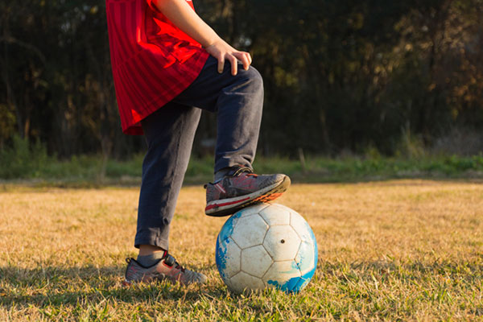

Physical aspect

A child, after conception, goes through various physical development. While home provides a restricted outlet, in school, a child can channelise his energy into more sociable avenues. Studies have pointed out that while in familiar environment, the child is equipped to deal with sudden bursts of energy, the learns to be at his/her best behaviour only when exposed to same-aged individuals. Plus, familiarity leads to taking advantage of situations, while in school, the playing field is levelled. Also, the presence of activities such as sports, craft help children direct their boundless energy into something productive.
Overall development

Earlier, schools were considered as places to learn events in history chapter, solve tough mathematical problems or recite poems and sonnets. In the current educational scenario, a child learns to go beyond the traditional way of rote learning. They are taught to develop a mind of their own and through the flexible curriculum, curiosity is promoted. The child is freed from the shackles of mental blocks and lets his/her imagination run its course. Importance of imagination is stressed upon extensively. Play inactions and an encompassing curriculum lead to a well-developed cognitive system.
Life is also about learning, apart from living. While we can learn to a certain extent from our parents, they tend to be unilateral. At school, children are exposed to various sources from whom they can imbibe immense knowledge, instrumental for their development. Hence school is necessary for children to inculcate the workings of life”
Education forms the foundation of any society. It is responsible for the economic, social, and political growth and development of society in general. The thread of the growth of society depends upon the quality of education that is being imparted. So schools play an important role in moulding a nation’s future by facilitating all round development of its future citizens.

- Objective/Scope of the project:
Main objective of this Community Service project is to create awareness on the advantages of Basic School education, to explain what is Basic education , usage in technology, development and present status among the families where the survey to be conducted.

- Data Analysis:
SKR & SKR Govt. DEGREE COLLEGE FOR WOMEN(A),KADAPA.
Y.S.R DISTRICT
NAAC RE-ACCARAGRATION “B” level
(Affiliated to YOGI VEMANA UNIVERSITY)
DEPARTMENT OF URDU
Questionnaire Of the SCHOOL EDUCATION SURVEY IN KADAPA

(A COMMUNITY SERVICE PROJECT)
STUDENT NAME | S.Tauseefa
A HALLTCKET NO | 21440117016 | YEAR | 1
SEMESTER(I/IV/VI) | 2 | Mentor name
COURSE | BA(UM | GROUP | HUCA/HUP
I.
1.NAME OF THE VILLAGE/PANCHAYTHI:bayanapalli
2.WARD/CORPORATION NO: 5 ward
3.Name of the corporate:T Chandra shekhar yadav
4.Name of the School MEO:L lrelavathi
5.Name of Voluntary:S.Subahan
6.Name of the Sarpanch T Chandra shekhar yadav
I .About the School:
- Date of Establishment the School:
2001
- Type of the School: (Govt./ZP/Private/Corporate)
Govt

- School status: ( High school/ Upper Primary/Primary/AaganVadi School

II. StudentsStrength of the school (Numbers)
s.no | class | High school |  | Upper primary |  | primary |  | AaganVadi School
 |  | Girls | Boys | Girls | Boys | Girls | Boys | Girls | Boys
1 | I |  |  | 7 | 2
2 | II |  |  | 3 | 5
3 | III |  |  | 10
4 | IV |  |  | 5
5 | V |  |  | 6
6 | VI | 30 | 20 | 5
7 | VII | 30 | 30 | 4
8 | VIII | 20 | 15
9 | IX | 20 | 20
10 | X | 50 | 15
III. Facilities Available in Schools (Yes/No/Numbers)
Facilities Available in Schools | High school | Upper primary | primary | AaganVadi School
Drinking water | Yes | Yes
Play ground | Yes | Yes
Compound wall | Yes | Yes
Garden | Yes | Yes
Library | Yes | Yes
Class rooms | Yes | Yes
Computers | Yes | No
Uniform | Yes | Yes
Toilet with running water for Girls | Yes | Yes
Toilet with running water for Boys | Yes | Yes
Black Board available | Yes | Yes
Smart Board | Yes | No
LCD Projector class room | Yes | No
Virtual Class Room | Yes | Yes
Labratory | Yes | Yes
Sports items | Yes | Yes
Teaching aids | Yes | Yes
IV. Furniture Available in Schools (Yes/No/Numbers)
Furniture | High school | Upper primary | primary | AaganVadi School
Tables | Yes | Yes
Chairs | Yes | Yes
Student benches | Yes | Yes
Cupboard for Teachers | Yes | Yes
Cupboard for Teachers | Yes | Yes
V. Mid-Day Facilities Available in Schools
Days | Meals/Rice | Dal/Curry | Curd | egg | Fruit
Mondays | Yes | Yes | Yes | Yes | No
Tuesday | Yes | Yes | Yes | Yes | No
Wednesday | Yes | Yes | Yes | Yes | No
Thursday | Yes | Yes | Yes | Yes | No
Friday | Yes | Yes | Yes | Yes | No
Saturday | Yes | Yes | Yes | Yes | No
VI. Teachers (Numbers):
Subject teachers | High school |  | Upper primary |  | primary |  | AaganVadi School
 | Men | Women | Men | Women | Men | Women | Men | Women
English | Yes | No |  | Yes
Telugu | No | Yes | Yes
Hindi | Yes | No |  | Yes
Urdu |  |  |  | Yes
Social | Yes |  |  | Yes
Science | Yes |  | Yes
maths |  | Yes | Yes
computer |  | Yes | Yes
VII. Building Facilities Available in Schools (Yes/No/Numbers)
Type of Building | High school | Upper primary | primary | AaganVadi School
Concrete Building with ground Floor | Yes | Yes
Concrete Building with ground one Floor | Yes | No
Concrete Building with ground 2 Floor | No | No
Building with Ruff | No | No
Shed type | No | No
In House | No | No
Open School | No | No
VIII.Access from population /Distance/ Road Facility:
Access /Distance/ Road Facility | High school | Upper primary | primary | AaganVadi School
Kilometres | 3 | 2
Kach-cha Rasta | No | No
Tar Road | Yes | Yes
Auto Facility | Yes | Yes
Bus Facility | Yes | Yes
Parents drop | Yes | Yes
Walkable | No | Yes
IX. Type of School Syllabus:
Type of School Syllabus | High school | Upper primary | primary | AaganVadi School | Private school
CBSC | No | No
State syllabus | Yes | Yes
Semester wise | No | No
Year wise | Yes | Yes
X. Type of Population in surrounding the schools
 | Girls/women | Boys/men
Students | 20 | 7
Dotors | No | 1
Labor | 15 | 35
Tailor | 25 | 5
Auto driver | No | 12
Working Women | 4 | 17
Child Labor | No | No
XI. AvailableFacility surrounding the schools:
Hospital | Yes
Book stall | Yes
Canteen | Yes
Play ground | Yes
Central library | No
Children’s Park | No
Zoo | No
XII. Teaching methods:
. Teaching methods ... | High school | Upper primary | primary | AaganVadi School | Private school
The Direct Method | Yes | Yes
The Grammar Translation Method. ... | Yes | Yes
The Audio Lingual Method. ... | Yes | Yes
The Structural Approach. ... | Yes | Yes
Suggesttopediagology. ... | Yes | Yes
Total Physical Response. ... | Yes | Yes
Communicative Language Teaching (CLT) ... | Yes | Yes

- Results and Discussion:
As per the survey report most of the people are unaware of Basic School education and their benefited without education which type of problems are facing. In most of the families, people of the age above 65 years are not interested in female child education. Most of the families and youth are interested to feed their children at list basic education. Most of the families trust in education, quality of the school education. Only limited people are aware of compulsory education & child labour act.

- Conclusion:
- Education for Justice
- Alternative education – Term referring to forms of non-mainstream educational approaches
- Belding
- Co-teaching
- Comprehensive sexuality education – Sexuality education instruction method
- Education for Sustainable Development
- Educational technology – Use of technology in education to improve learning and teaching
- Glossary of education terms – Wikimedia list of lists
- Human rights education – Education on the topic of human rights
- Index of education articles – Wikipedia index
- List of education articles by country
- Mixed-sex education – System of education where males and females are educated together
- Outline of education – Overview of and topical guide to education
- Pedagogy – Theory and practice of education
- Progressive education – Pedagogical movement
- Right to education – Human right
- Sociology of education – Study of how public institutions and individual experiences affect education and its outcomes
- Student – Learner, or someone who attends an educational institution
- School – Institution for the education of students by teachers
- School uniform – Standardized outfit worn by students of an educational institution
- Unschooling – Educational method and philosophy; form of homeschooling
- Education in Islam – Islam and education

- Education makes you a better person and teaches you various skills. It enhances your intellect and the ability to make rational decisions. It enhances the individual growth of a person. Education also improves the economic growth of a country.
- Evaluations help teachers become better teachers. Evaluations must be fair, ongoing, and meaningful. There are two distinct roles within the process, one for teachers and another for administrators. Evaluation participants must be brutally honest and open with each other.

- Photo Gallery:

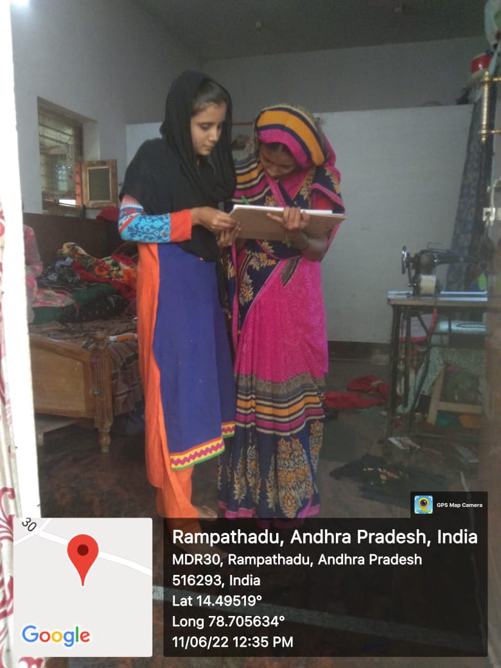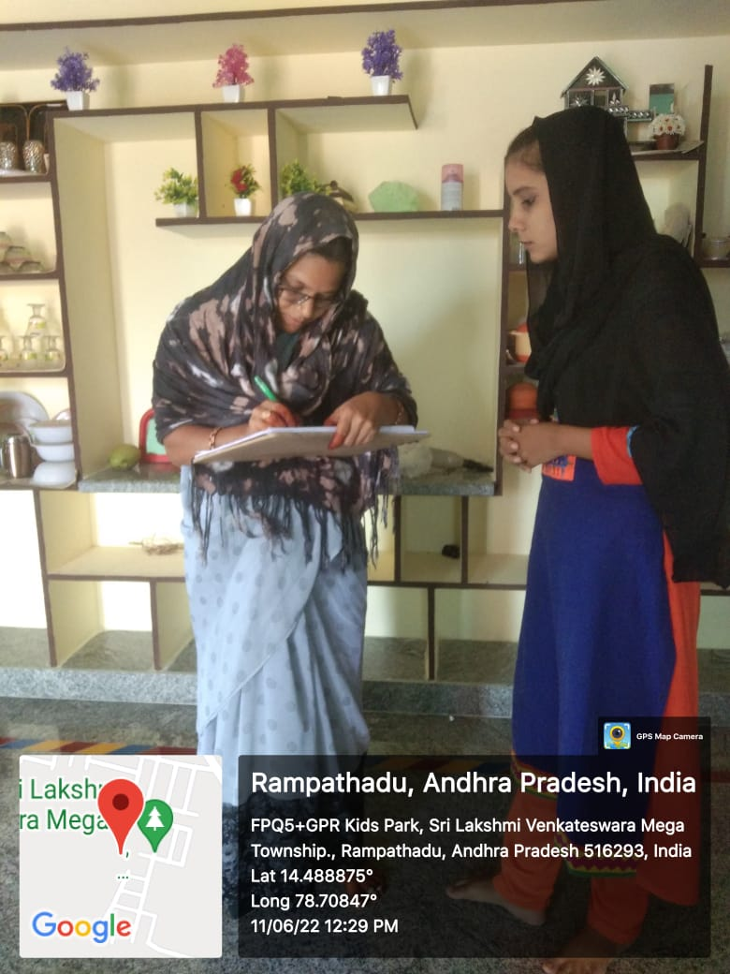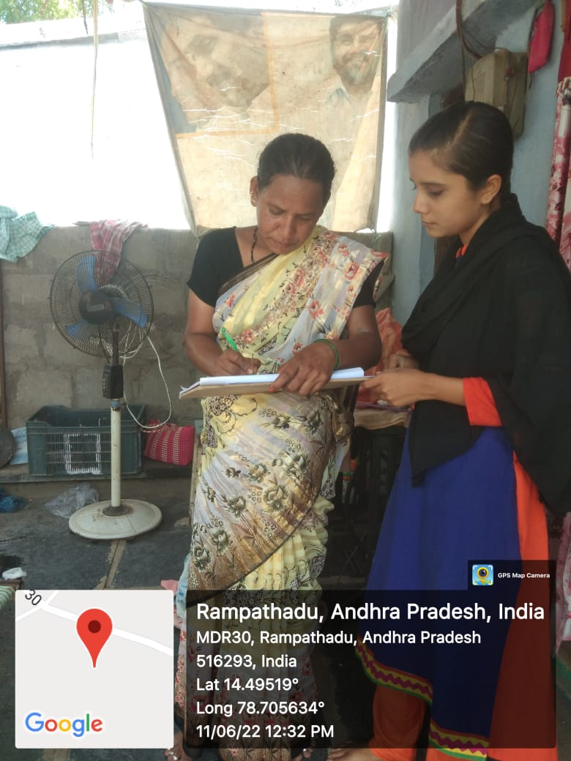

References:
- Singh, M. (2015). Global Perspectives on Recognising Non-formal and Informal Learning: Why Recognition Matters. Springer-UNESCO. https://doi.org/10.1007/978-3-319-15278-3
- ^ Livingstone, D. W. (2005). Expanding conception of work and learning: Research and policy impli-cations. In K. Leithwood, D. W. Livingstone, A. Cumming, N. Bascia, & A. Datnow (Eds.), International handbook of educational policy (pp. 977–996). New York: Kluwer Publishers.
- ^ Jump up to:ª ^{b} ^{c} ^{d} Marshall, James D. (2006). "The Meaning of the Concept of Education: Searching for the Lost Arc". Journal of Thought. 41 (3): 33–37. ISSN 0022-5231. JSTOR 42589880.
- ^ Jump up to:ª ^{b} ^{c} ^{d} ^{e} ^{f} ^{g} ^{h} ^{i} ^{j} ^{k} ^{l} Curtis, Will; Ward, Stephen; Sharp, John; Hankin, Les (6 December 2013). "1. What is education?". Education Studies: An Issue Based Approach. Learning Matters. ISBN 978-1-4462-9693-6.
- ^ Matheson, David (2014). "What is education?". An Introduction to the Study of Education (4 ed.). Routledge. pp. 15–32. doi:

$$$$$$$

